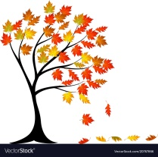
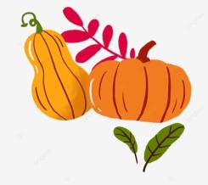
Dinas
Autumn Show
Horticulture and Crafts
Saturday 30th September 2023
Yr Hen Ysgol, Dinas Cross

Free entry, free viewing.
Entry forms and class information will be available at local businesses in Dinas and on the day.
Entries to be received between 11am – 12.30pm
Judging between 1pm – 2pm
Open to the public at 1pm for refreshments, viewing of exhibits 2pm-4pm
Raffle and children’s autumn quiz.

10am -12pm Children’s Lego activity, Lego provided, come and make a model and enter it into the show.
Rosettes for winners, prizes for all child entries.

Donations gratefully received, all proceeds to Yr Hen Ysgol.

